**1 董一廷**

脉冲神经网络，类脑计算，无监督可塑性

spiking neural network，brain-inspired computing，unsupervised plasticity learning

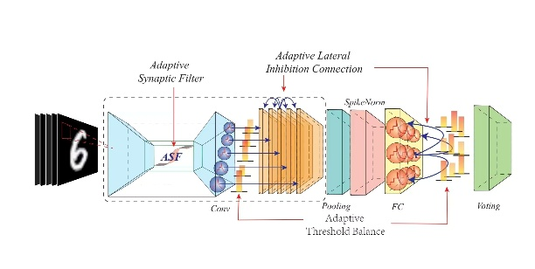

**2 陈野**

类脑视觉解码研究 Brain-like Visual Decoding

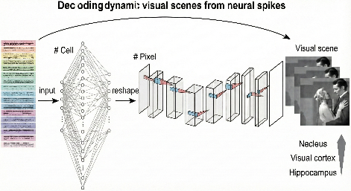

**3 贾杉杉**

类脑计算与计算神经科学 brain-inspired computing and computational neuroscience



**4 郝泽成**

面向脉冲神经网络的高性能学习算法

High-Performance Learning Algorithms for Spiking Neural Networks

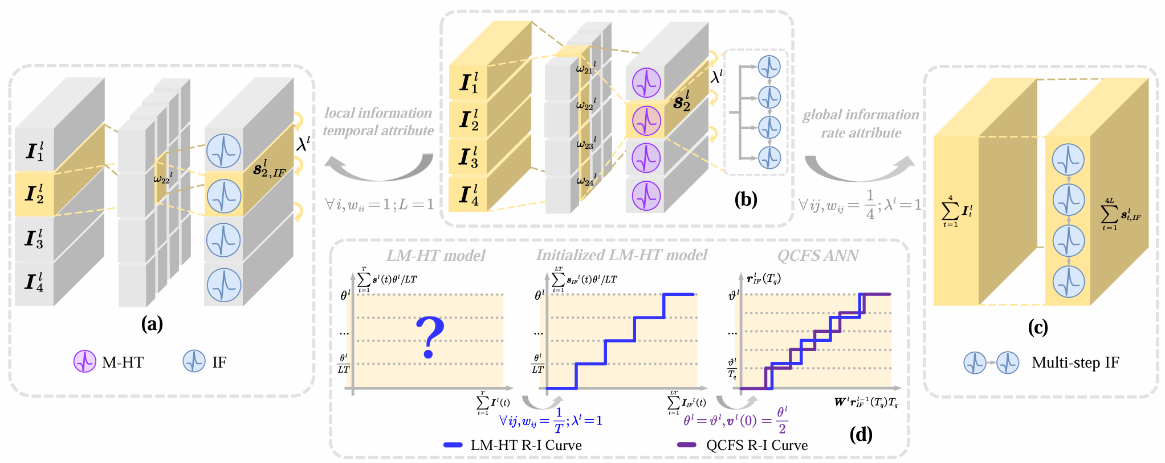

**5 卢懿**

脉冲神经网络，神经编码

spiking neural network, neural coding

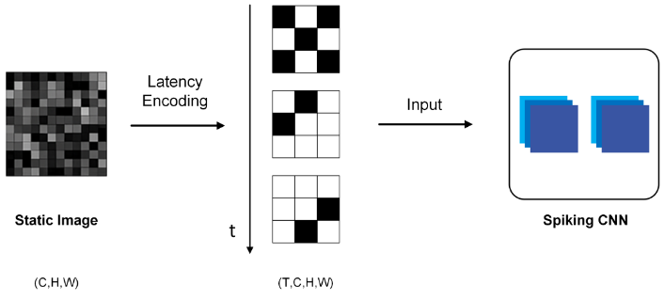

**6 苏长青**

ultra-fast 3D imaging and brain-inspired vision 超快三维成像，类脑视觉

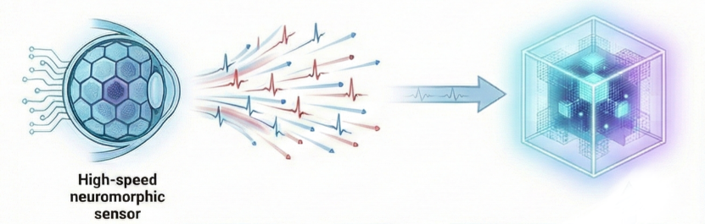

**7 马启超**

高效神经形态计算部署 Efficient Neuromorphic Computing Deployment

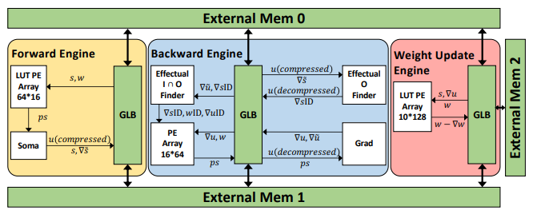

**8潘致宇**

神经形态相机像素差异化内参标定

Neuromorphic Camera Pixel-Wise Differential Intrinsic Calibration

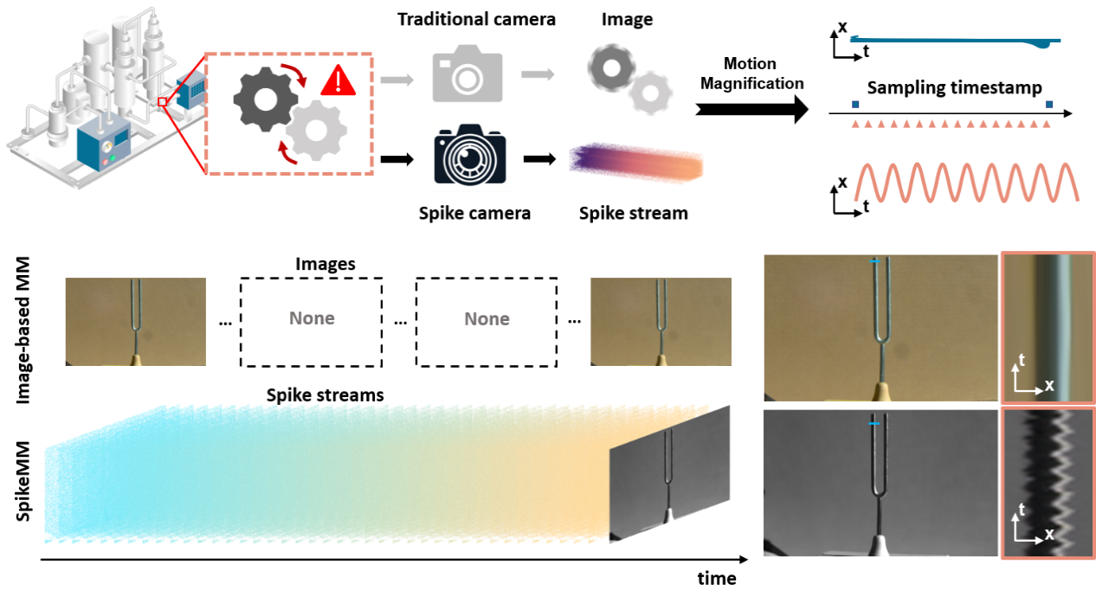

**9 马鹏**

Neuromorphic Vision，Object Detection

神经形态相机目标检测算法

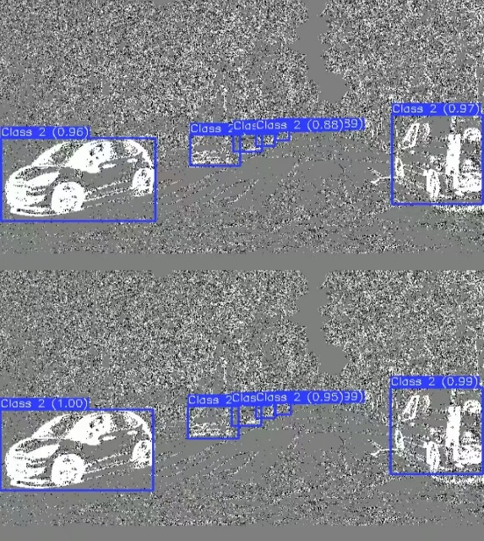

**10 施新宇**

脉冲神经网络剪枝算法

Pruning method for Spiking Neural Networks

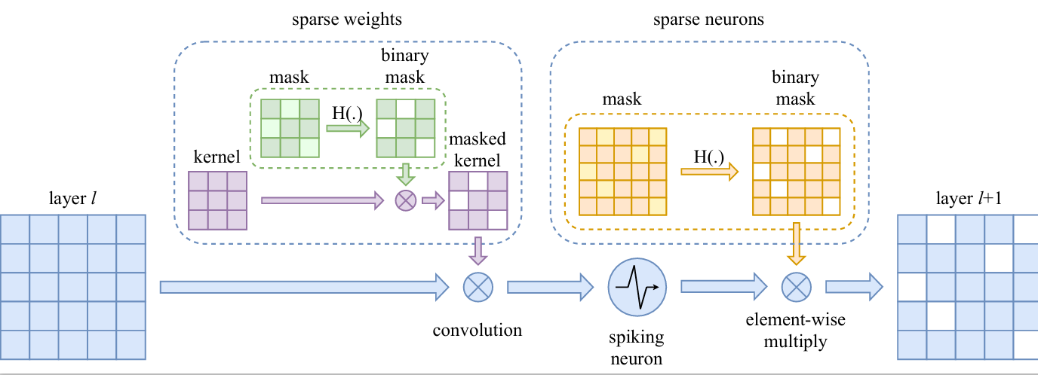

**11 陈康**

脉冲成像计算，三维视觉

spike camera，3D Vision

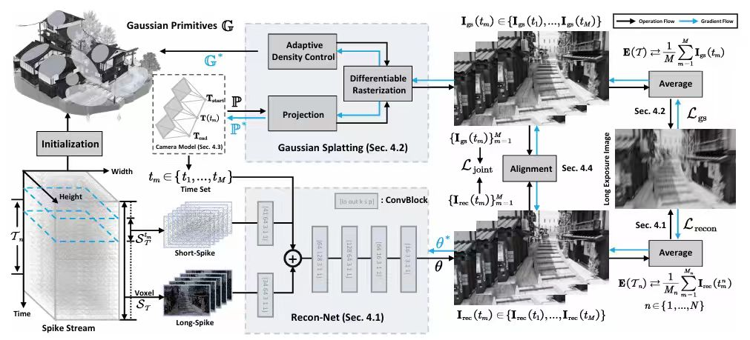

**12 徐梓杰**

脉冲神经网络 强化学习

Spiking Neural Networks, Reinforcement Learning

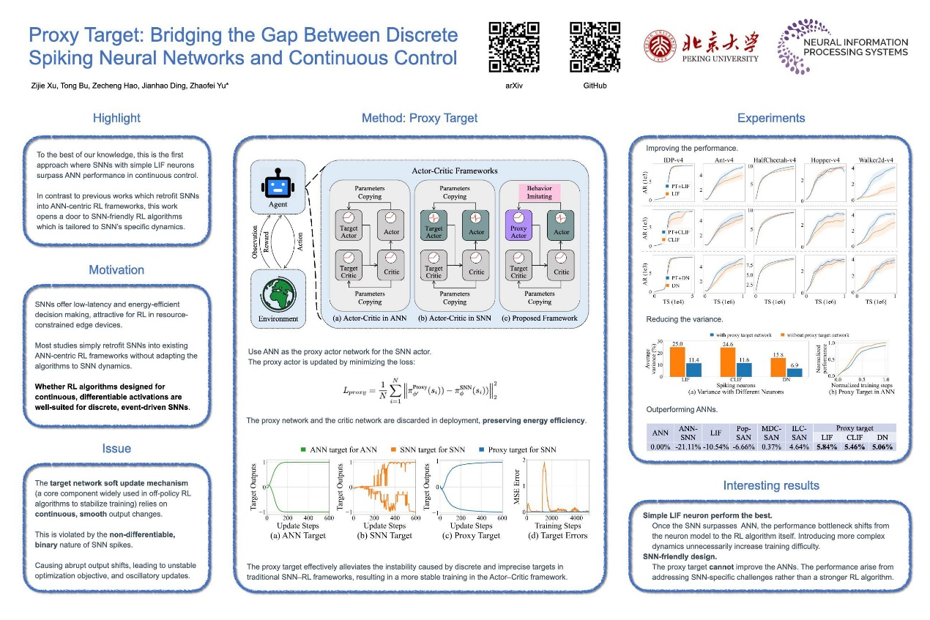

**13丁健豪**

脉冲神经网络，类脑计算

spiking neural network，brain-inspired computing

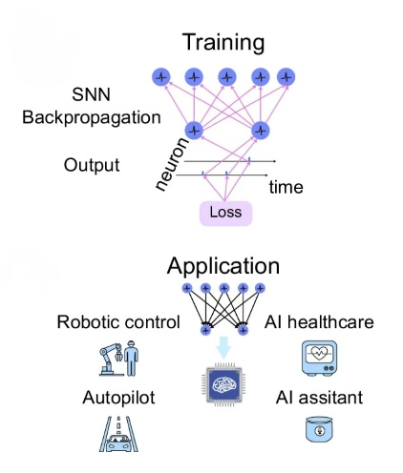

**14 张文翰**

ANN-to-SNN conversion 人工神经网络到脉冲神经网络的转换

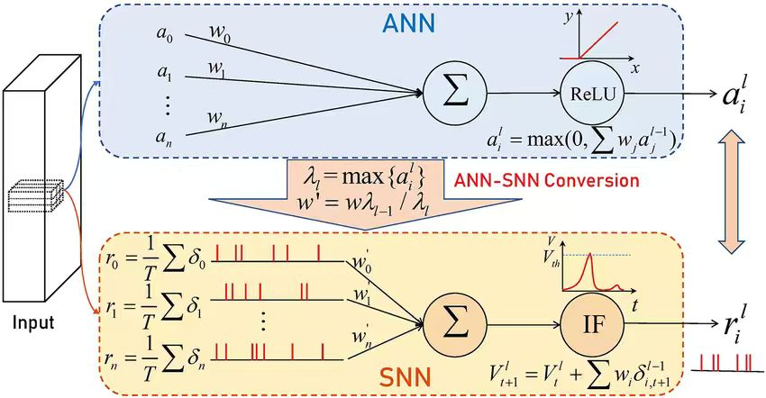

**15 张宝月**

神经形态相机，机器人

Neuromorphic Vision，Embodied AI

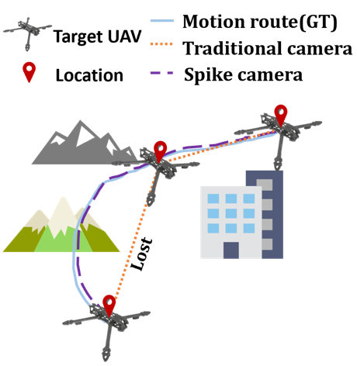

**16 陈子睿**

脉冲神经网络 ann转snn、snn剪枝

Spiking Neural Network，ANN-to-SNN Conversion，SNN Pruning

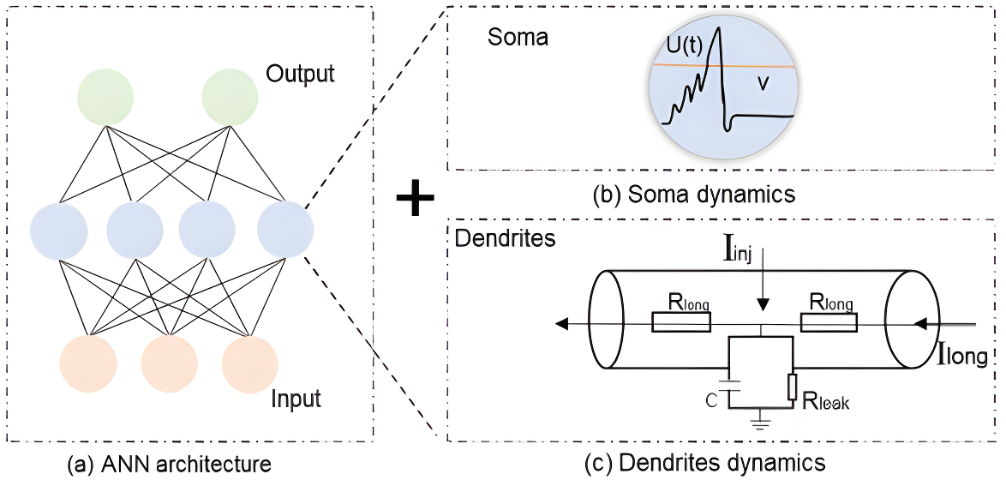

**17 刘沛雨**

计算神经科学 computational neuroscience



**18 郭秉睿**

脉冲相机、具身智能

Spike Camera，Embodied AI

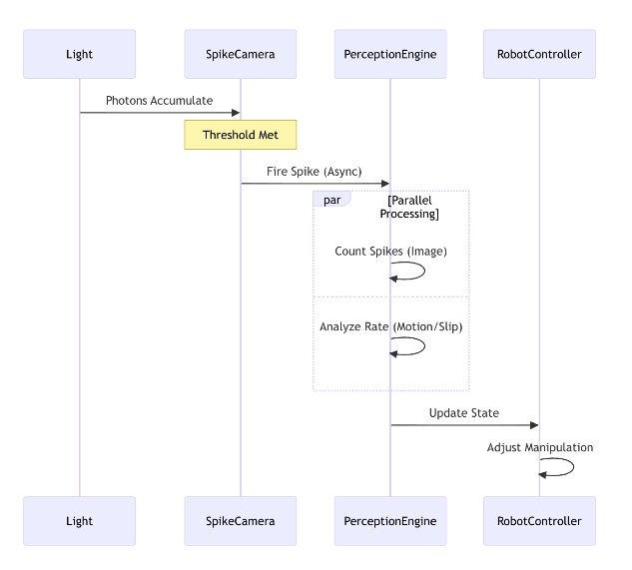

**19 黄梓涵**

脉冲神经网络 ann转snn

Spiking Neural Network，ANN-to-SNN Conversion

